# Single Particle Tracking

Upon setting « *sptPALM* » to *on* in the main SMIS window, you will be able to set up diffusion and directed motion parameters for each fluorophore. Select the fluorophore you want to address and the following window will appear:

**8**

**9**

**7**

**6**

**5**

**4**

**2**

**1**

**3**

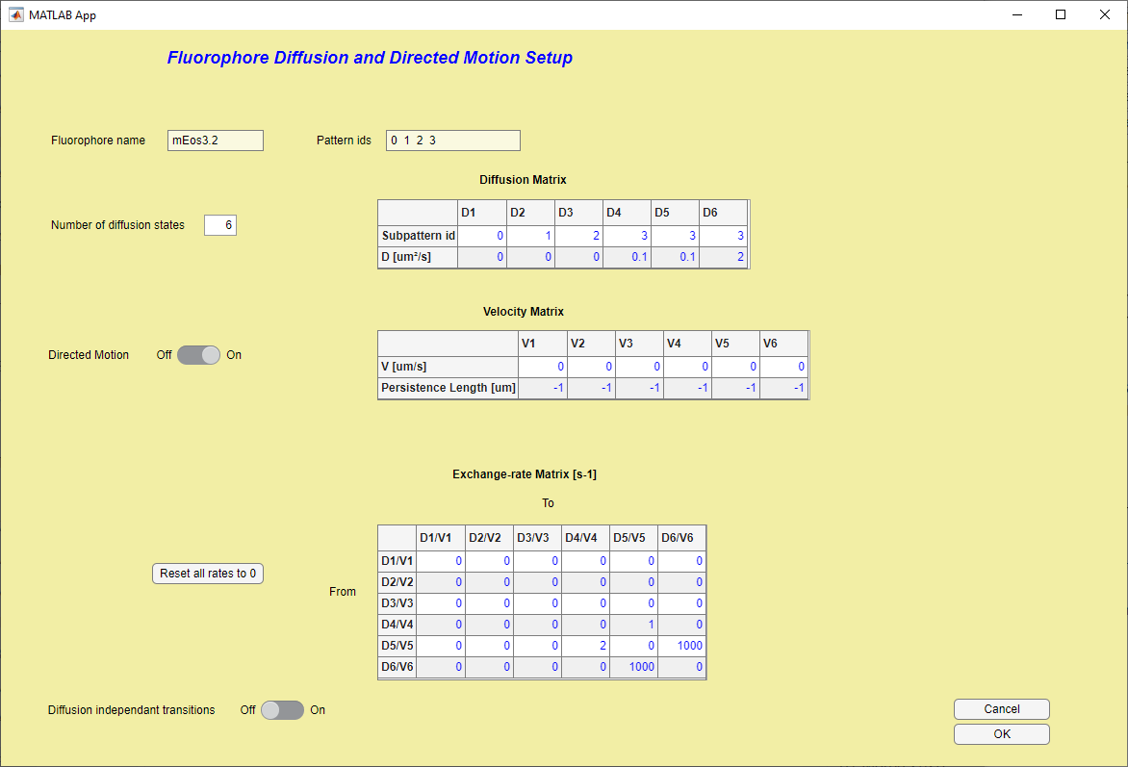

1. The name of the fluorophore is indicated here
2. The different *pattern IDs* of the virtual sample associated to that fluorophore are also indicated (see chapter on Virtual samples)
3. Choose the number of diffusion states that the fluorophore can have. Note that a minimum of 1 diffusion state should be defined for each pattern ID in the virtual sample.
4. Fill up the corresponding Table. For each diffusion state, give the value of the diffusion coefficient and the pattern ID where the single molecules may take this diffusion state. You can set multiple diffusion states for a single pattern ID, ie single molecules may change their diffusion states within a single compartment of the virtual sample.
5. In addition to diffusion, you may add directed motion, according to the same principle.
6. Fill up the corresponding Table. For each diffusion state, give the value of the velocity and corresponding *persistence length*: the persistence length indicates the typical distance over which the pattern ID does not change its orientation, that is the distance over which molecules should travel in a rather straight manner. Use a value of -1 for automated determination of the persistence length. A long straight filament should have a long persistence length whereas the bulk of the cytoplasm of a cell for example should rather have a short persistence length.
7. Can change their diffusion state according to defined kinetics. If this is the case, indicate the exchange rates in this table. This can be from one subpattern to another, or within a single subpattern.
8. You may reset all rates to 0 if needed.
9. You may want to select this option to force a possible transition to a new pattern ID even if the molecule did not move to that pattern. This mimics molecular unbinding in e.g. PAINT experiments, where the unbinding rate is *not* diffusion dependent. Thus, this option should only be used for patterns IDs that are very thin, otherwise it does not make sense, as the molecules will jump a long way. If you select this option, fill up the table to decide to which diffusion states the option should be applied:

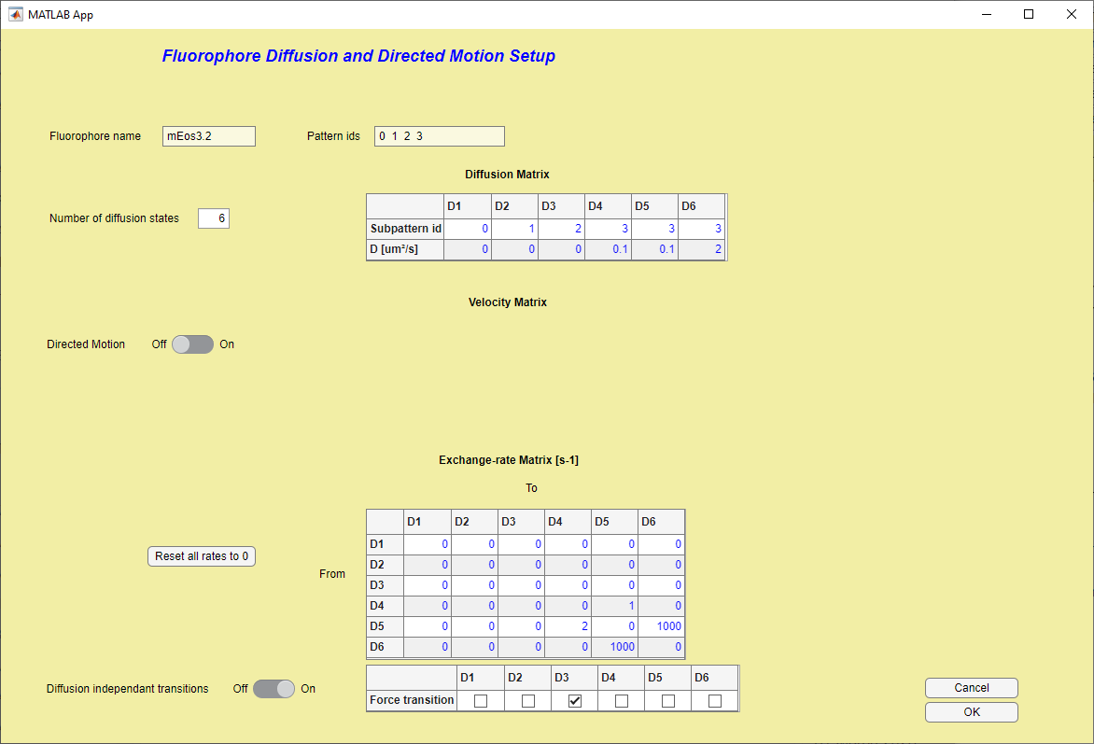

# sptPALM options

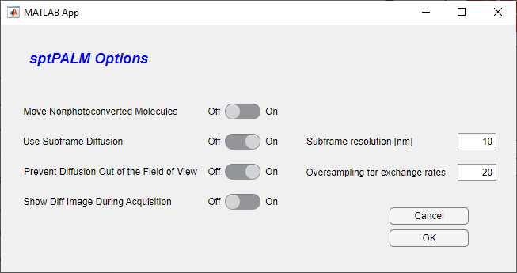Upon selecting « *sptPALM* *options*» in the main SMIS window, the following window will appear:

**4**

**3**

**6**

**5**

**2**

**1**

1. Set this switch to *On* if the fluorophores that have not yet been photoconverted are to be moved according to the diffusion states. As these molecules are typically not visible, this represents potentially non-useful extra calculations. Of course this only makes sense if you are using a photoconvertible fluorophore !
2. Use this option to perform subframe diffusion calculations. This is more realistic and should be the preferred option but represents a significant increase in computing time. As a consequence of this, the PSF of the moving molecules may appear smeared according to the motion that occurs during frametime
3. If *Use subframe diffusion* is chosen, this value sets the resolution (basically the distance a molecule must travel for a new calculation to be performed) for the subframe diffusion calculation. The smaller the value the better, at the cost of increased computing time.
4. If *Use subframe diffusion* is chosen, this value sets the oversampling factor for exchange rates between different diffusion states. It is possible to use a value << 1 (ie you do not care when a diffusion change occurs within the frame time) to speed up calculations e.g. for PAINT simulations.
5. Use this option to prevent moving molecules to move out of the field of view. This can be useful for example if molecules are diffusing in the background and you don’t want to “lose them” to keep a fixed effective concentration, e.g. in PAINT.
6. 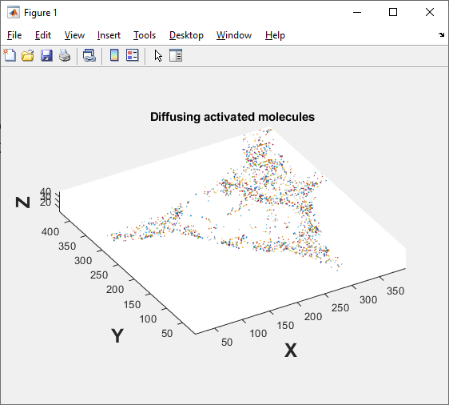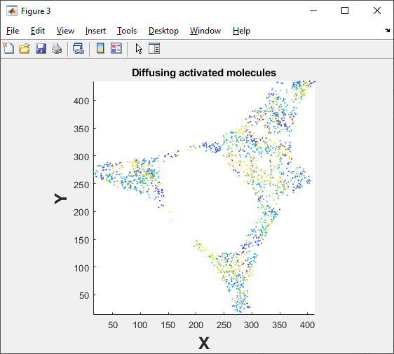Use this option to visualize moving molecules in an extra Matlab figure during data acquisition. This will look like this for 2D or 3D experiments:

# Other SMIS features

## Monitoring what’s going on

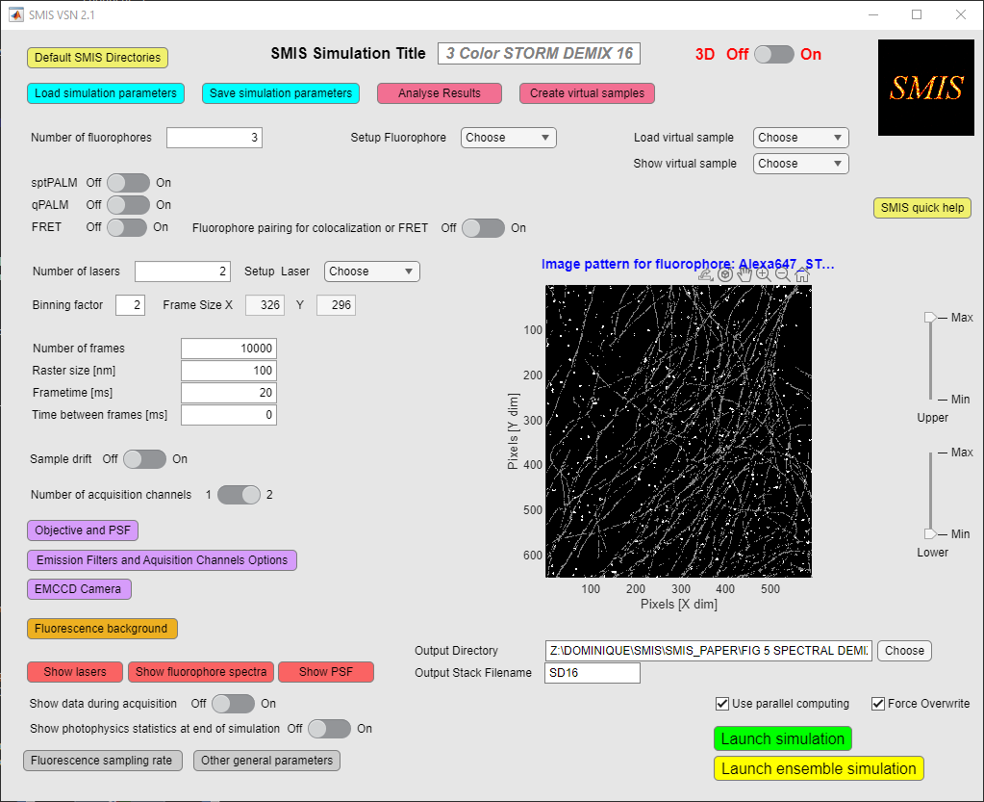At the bottom of the main SMIS window, you can use the 3 red buttons to look at lasers, fluorophore spectra and point spread functions:

### Lasers

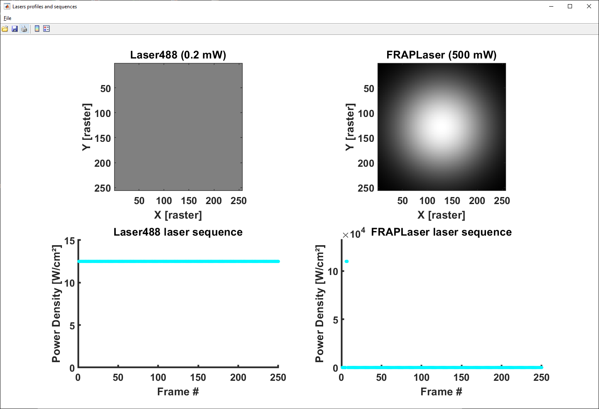Click the « *Show lasers* » button to show a summary of the defined lasers, as in the example below:

### Fluorophore spectra

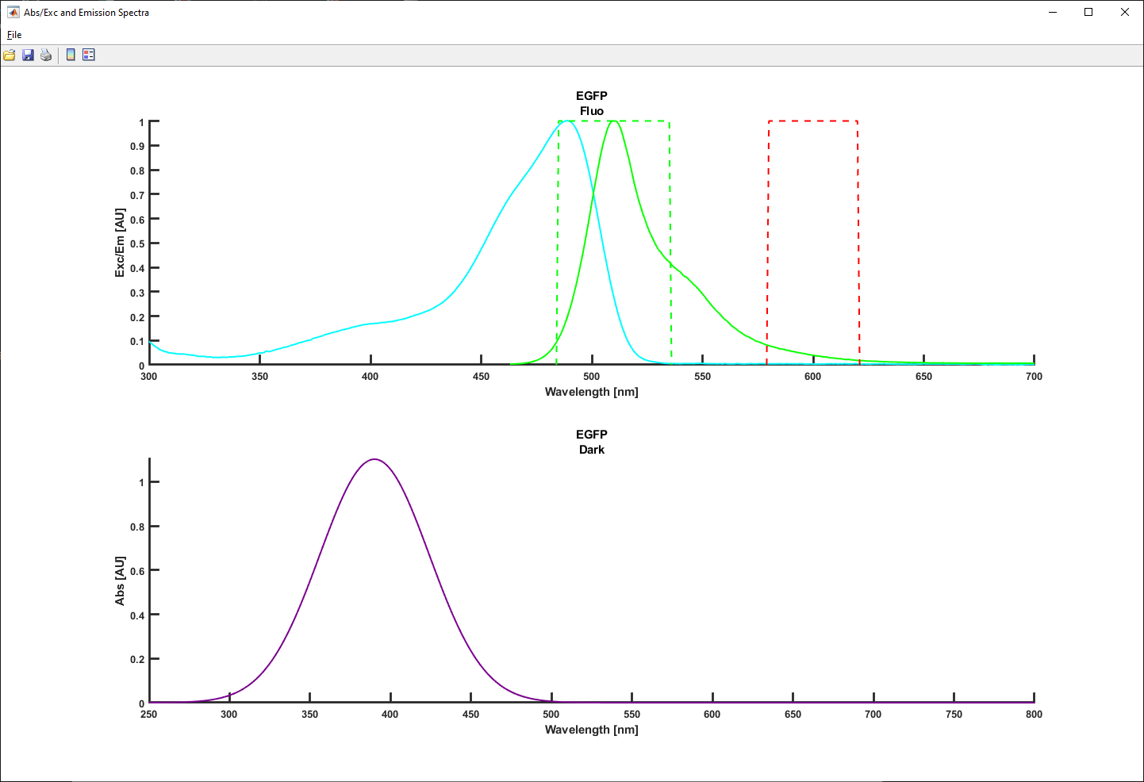Click the « *Show fluorophore spectra* » button to show Absorption/Excitation and fluorescence emission spectra of the fluorophores, as in the example below:

### PSF

Click the « *Show PSF* » button to show the point spread function corresponding to each fluorophore in all their fluorescent states for each channel, as on the examples below (2D and 3D):

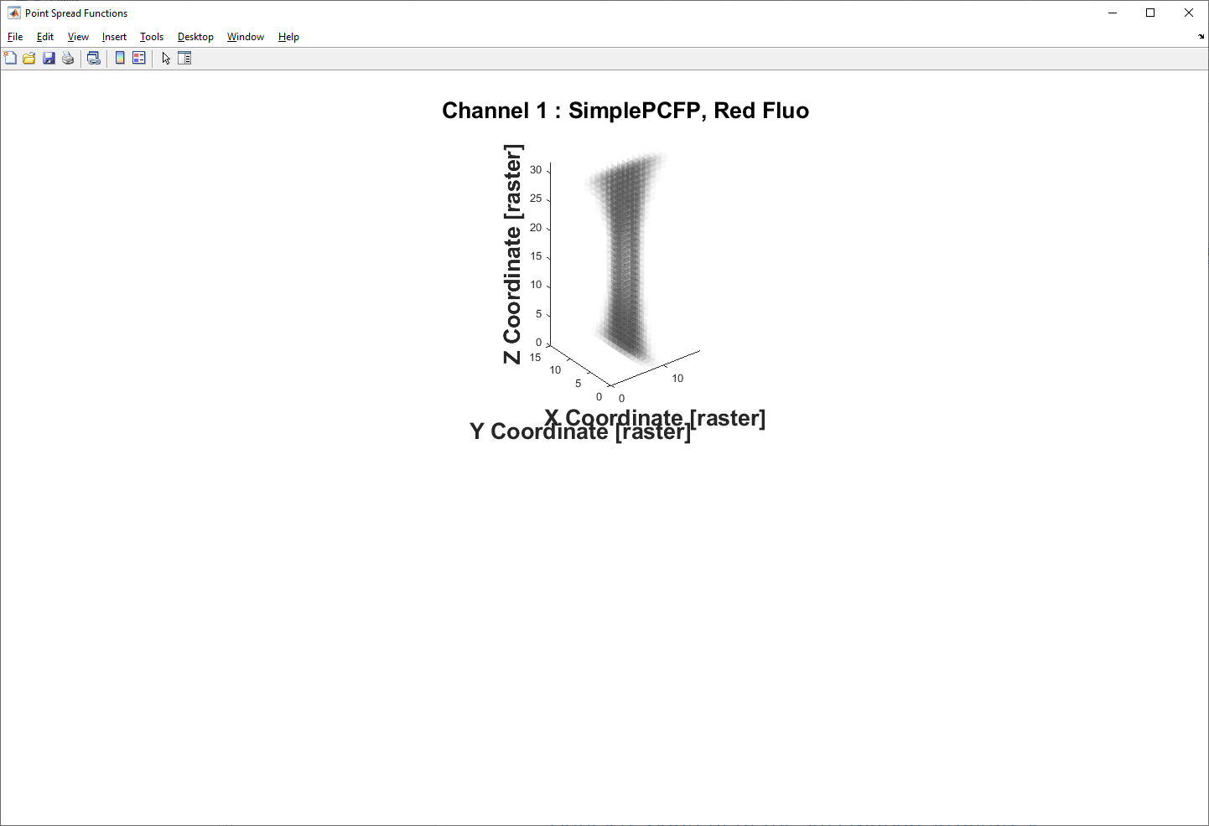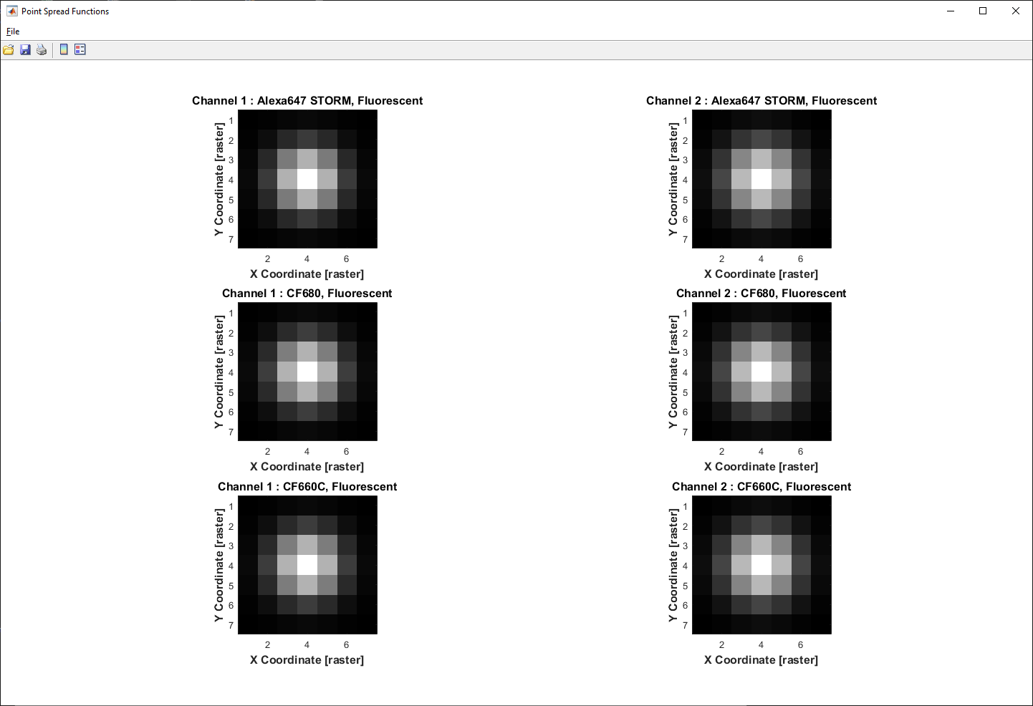

**In 2D**

**In 3D**

### Monitoring data collection

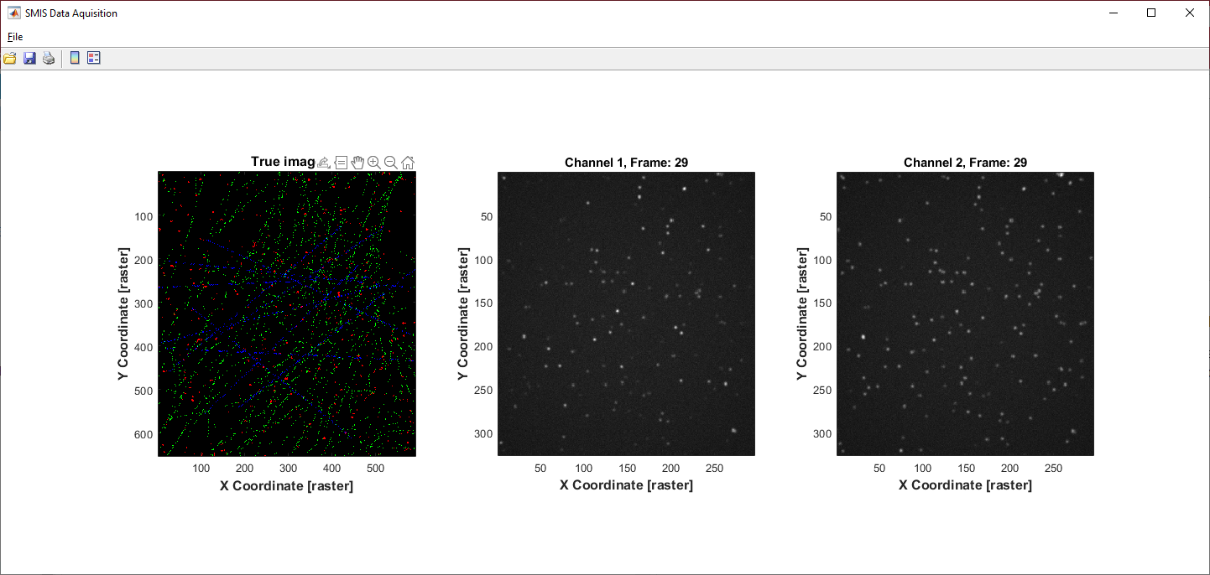Set « *Show that during acquisition* » to *on*, to visualize the generated frames during simulation. You will see on the left the ground truth fluorophores decorating the virtual sample, and on the right the collected frames, either one channel or two channel.

**Setting this option on significantly slows down SMIS, so it is advisable to only use this when setting up the simulation, not for the final run.

### Monitoring photophysics

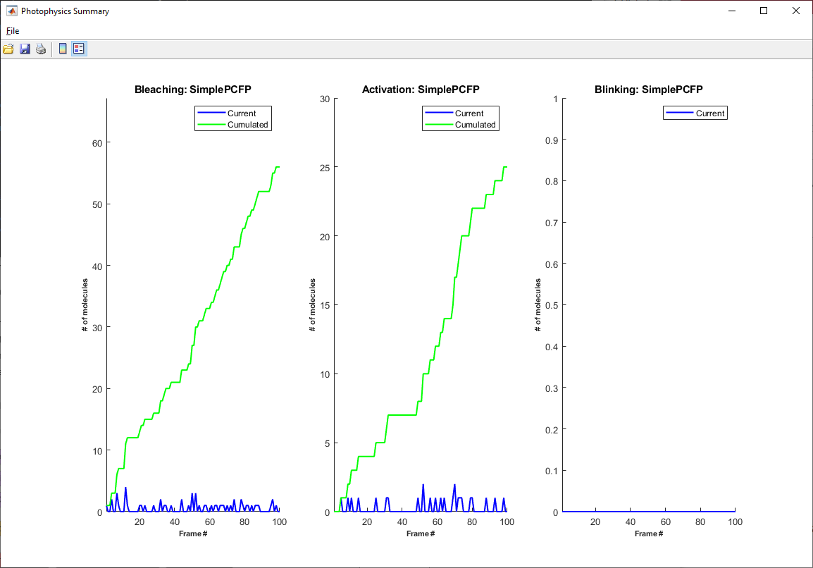Set « *Show photophysics statistics at end of simulation*» to get a grasp of the photophysical states of the fluorophores along simulation.

## Parallel computing

You can use parallel computing in SMIS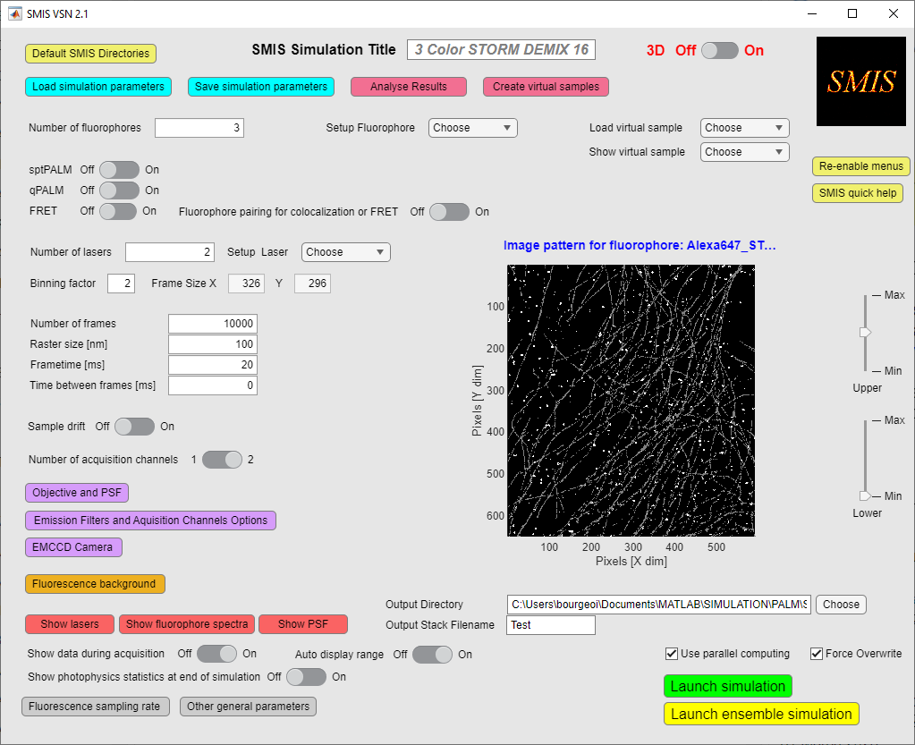 by ticking « *Use parallel computing* »

Parallel computing is generally useful when you have long simulations to run with many molecules per fluorophore. Note that starting parallel computing takes time, so there will be a lag in starting SMIS simulations. Typically also the first few frames will be quite slow, and then there will be a very significant acceleration. The efficiency of parallel computing really depends on the type of simulation you are running, and is not guaranteed. The speed increase will not be proportional to the number of available CPUs, although the SMIS code has been designed to cope at best with the requirement of parallel computing. We typically observe a maximum speed gain of a factor of 4 to 5 in simulations adequate for parallel computing, ie with > 1000 molecules.

**If you are running quick simulations with few molecules, there will be a strong time penalty in using parallel computing

As explained in the section “Other general parameters”, you can set the minimum number of molecules required to allow turning on parallel computing: below this number, even if parallel computing is set on, it will be turned off because it will be very inefficient. During a simulation starting with a high number of molecules, when the number of unbleached molecules will become below the entered minimum number, parallel computing will be automatically switched off.

## Force overwrite

You can force overwriting simulation data without confirmation by ticking « *Force Overwrite* »

# Launching simulations

Before launching a SMIS simulation, define the location of the output data:

And maybe save again the simulation parameters:

When you are finally ready to launch your simulation, you can do it either at the single molecule level or at the ensemble level.



Click on « *Launch simulation* » for single molecule simulation and click on « *Launch ensemble simulation* » for an ensemble level simulation. Ensemble level simulations will run a lot quicker, and are very useful to check parameters and notably the evolution of populations of photophysical states along the planned data collection scheme.

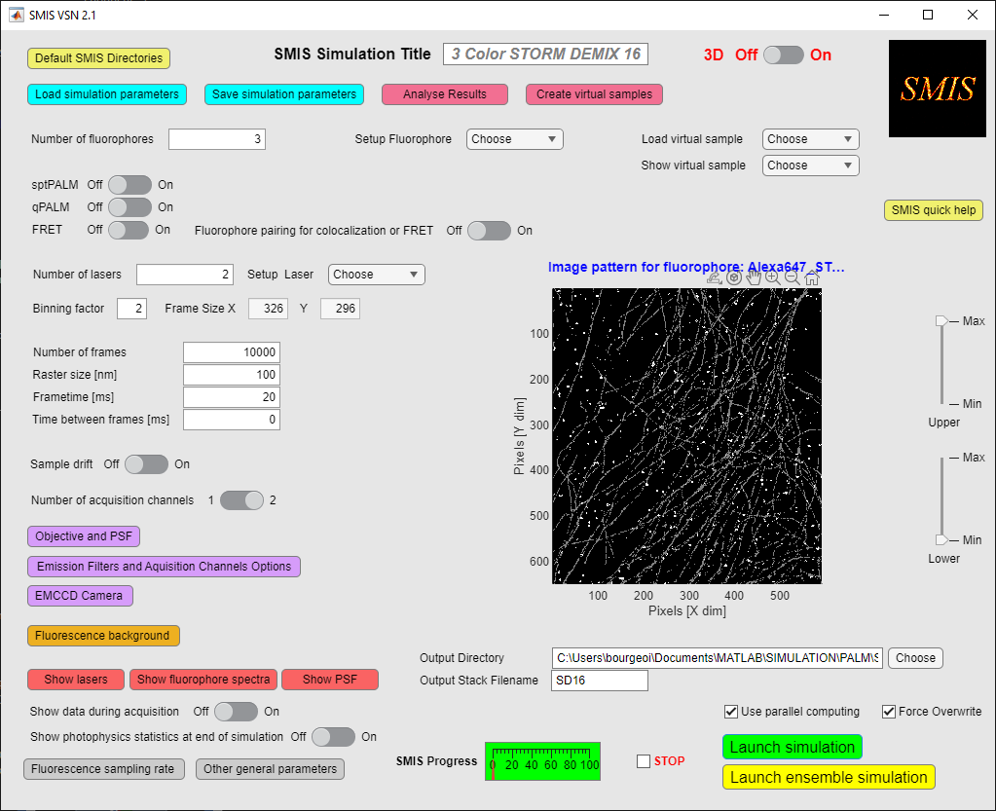Once assimilation has been started, you can monitor its progression and stop it by clicking on the « *Stop* » button.

**Stopping a simulation can lag for a number of frames depending on the case. Just be a little patient !

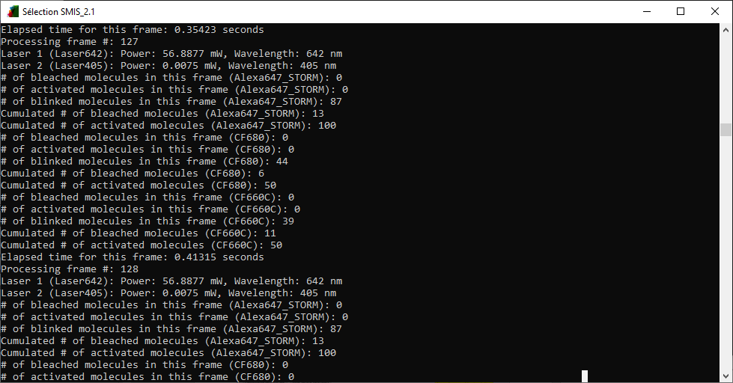A lot of information on the progress is display on the SMIS monitoring window (Standalone SMIS) or on the Matlab command window.

# Output Data

SMIS will generate a series of output files. If your simulation is named “MySMIS”, the following files are created:

1/ Image stack (“*MySMIS_ch1.tif*”). If 2 acquisition channels are used with 2 virtual CCD cameras, a second image stack is output (“*MySMIS_ch2.tif*”).

2/ A diary file (“*MySMIS_diary.txt*”), describing the progress of the simulation.

3/ A Matlab file (“*MySMIS.mat*”), containing the ground truth information for the fluorophores (see Annexes).

4/ Projections of the image stacks (“*MySMIS_ch1_dl.tif*”) (and possibly “*MySMIS_ch2_dl.tif*”), providing diffraction limited images of the sample.

5/ Beam profile for each laser (“*MySMIS_Mylasernames.tif”*).

6/ View of the ground-truth labeled virtual sample (“*MySMIS_true.tif*”)

# Creating virtual sample



Upon choosing « *Create virtual samples* » in the main SMIS window, the following window will appear:

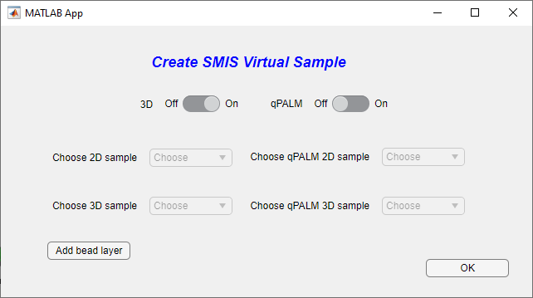Different types of virtual samples can be created, either for 2D or 3D SMIS simulations, and either for regular SMLM or for qPALM (see the chapter on virtual samples at the beginning of the SMIS manual). In 3D mode, you can add a “bead layer” to your sample, in case for example you want to simulate drift, and drift correction based on bead drift monitoring.

The number of possibilities offered by this SMIS tool is for now limited, but could be expanded in future versions of SMIS. Of course you can create more virtual samples using segmented images e.g. in Fiji or in Matlab.

Below 2 examples are given:

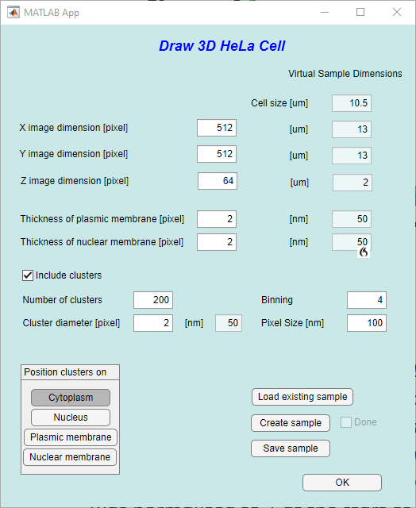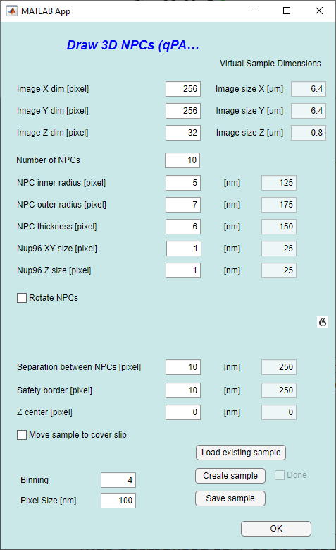

One important point to notice is that virtual samples are digital objects, so that you define dimensions in terms of pixel numbers, which are then converted into physical size through both the pixel size and the binning factor defined in SMIS. This is why the virtual sample dimensions is displayed on the right size, and change according to the chosen binning and pixel size. You will have to remember in SMIS simulations what binning and pixel size values correspond to which physical dimensions.

Note that you can also load an existing sample of the same type, to facilitate the creation of a new similar sample.

# Analyzing results



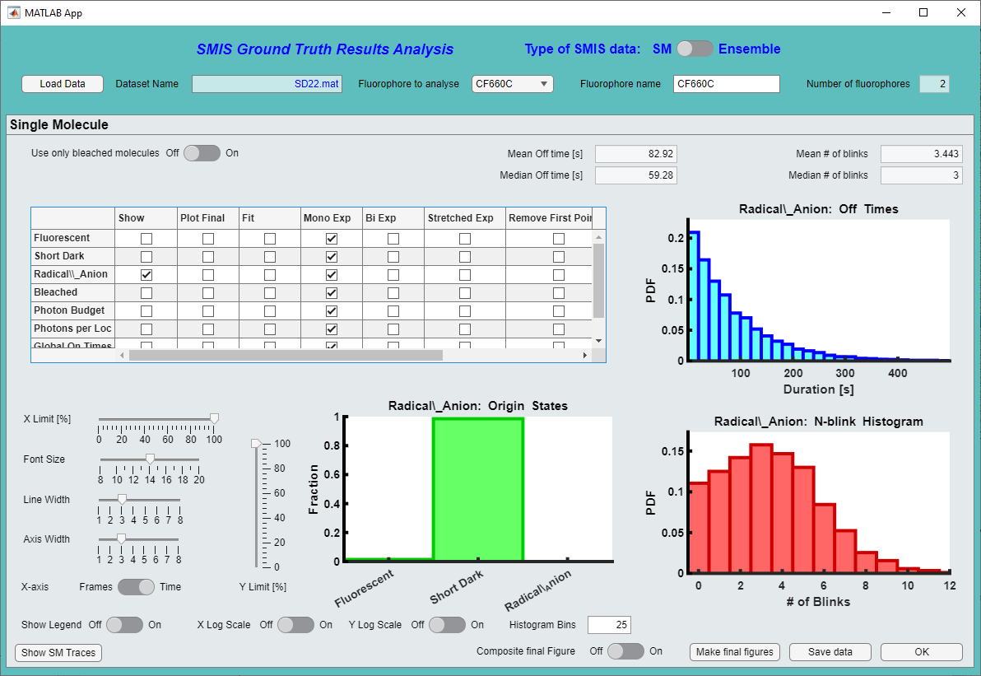Upon choosing « *Analyze Results* » in the main SMIS window, the following window will appear:

**9**

**8**

**7**

**6**

**5**

**4**

**3**

**2**

**1**

## Analyzing single molecule data

1. You can choose between analysis of single molecule (*SM*) or ensemble data (*Ensemble*). The window shown above is for single molecule data.
2. Then load the SMIS simulation ground truth output data of your choice (.mat file)
3. If this is a multicolor simulation, choose here the fluorophore you want to look at.
4. You may want to only select molecules that have “completed their whole life”, i.e. bleached molecules.
5. Select the photophysical state, or other photophysical parameters you want to look at. The other parameters are: photon budget (total number of detected photons before bleaching), photons per localization (number of detected photons per localization), global on times (i.e. on times as seen by the detector), global off times (i.e. off times as seen by the detector). For photon budget and photons per localization, if this is a multichannel experiment you can choose the channel in which to look at.  
   You can fit the histograms using monoexponential, bi-exponential or stretched-exponential models. Click on *fit* and select the type of fit, and then click again on *show* to display the fit. Fitting parameters are then displayed below the table, and the fit are overlaid on the histograms. You may want to remove the 1st point of the histogram when performing fits. For global on and off times you may choose a “blinking gap” to link *on* times separated by a few frames. You may also compute the histograms only from a defined frame number, in case for example you have a bleaching phase at the beginning of the data acquisition.  
   Use this parameters to adjust the plots the way you like.
6. You can play with data presentation using these various tools.
7. You can output a nice final figure. In the table select *Plot final* for those states or photophysical parameters that you want to plot, and then click on *Make final figure.* You can create individual output figures, or a single composite figure using the *Composite final figure* switch*.* In the latter case you may have to expand the output figure to nicely see the plots.
8. You can save the analyzed data for further inspection within Matlab.
9. 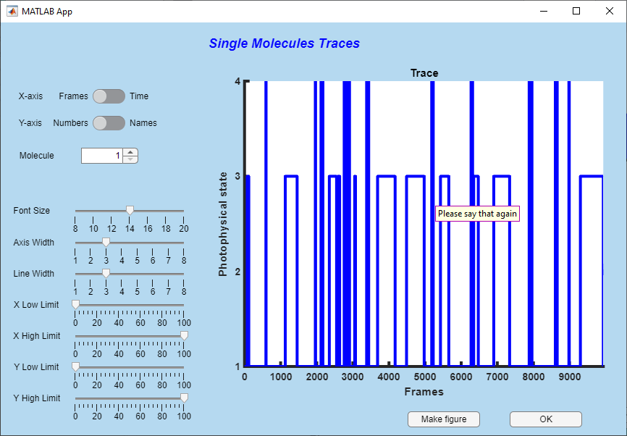You can look at single molecule traces individually. This will open a new window:   
     
   Enjoy looking at your traces, you can create a figure if needed.
10. If you are looking at SPT data, you will have the option to look at the tracks:  
      
    This will open the following window. Note that a number of calculations will be performed to calculate tracks, segments, mean square displacements, jump distances etc …

**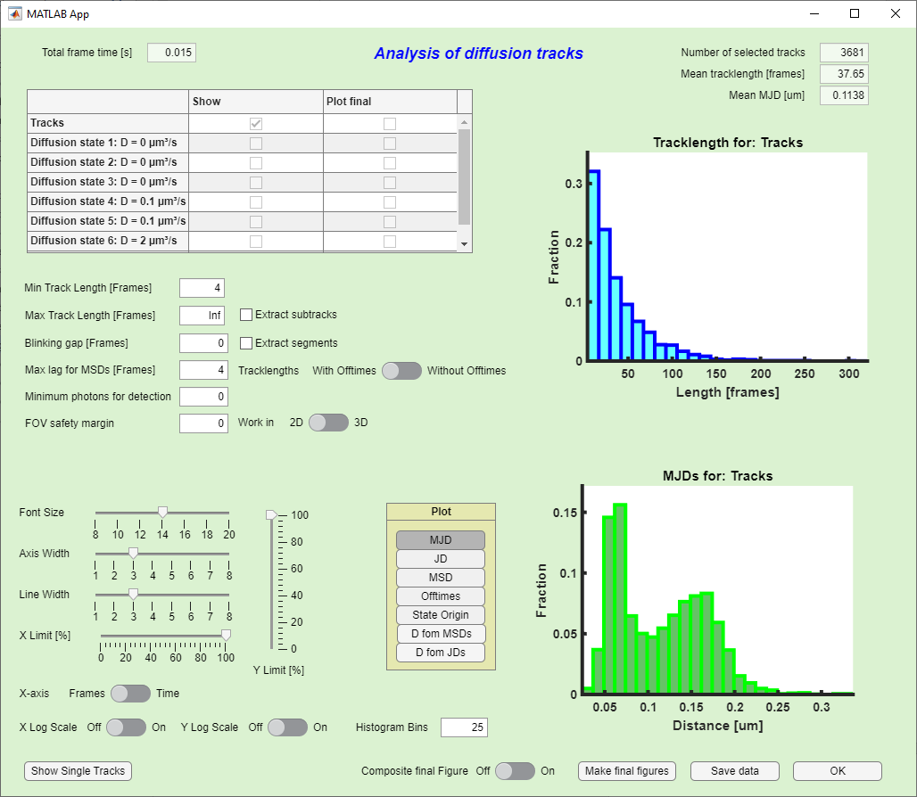  
You can do quite many things here: look at entire tracks, subtracks (pieces of tracks that are separated by long off times) or segments (pieces of tracks that correspond to a certain photophysical state). You can choose parameters to refine the ensemble of tracks or subtracks you want to look at. For each of those, you can plot jump distances, mean square displacements, and calculate diffusion coefficients. You can fit diffusion coefficient histograms with various models.

Calculations can take quite long … be patient !

A detailed description of all what you can do is left for the next version of this manual … But look at the online help by moving the mouse over the different buttons.  
  
Finally you can also look at individual tracks, in 2D or 3D:

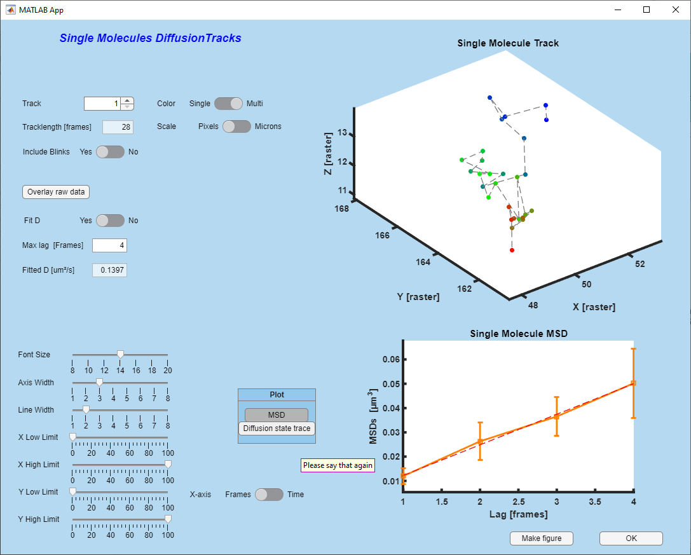

And you can even overlay tracks on raw data:

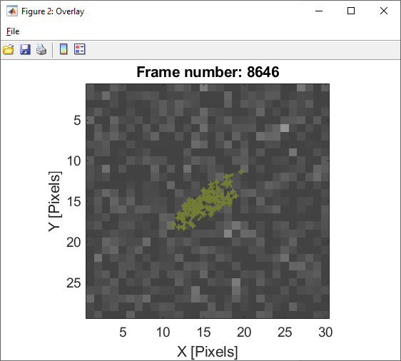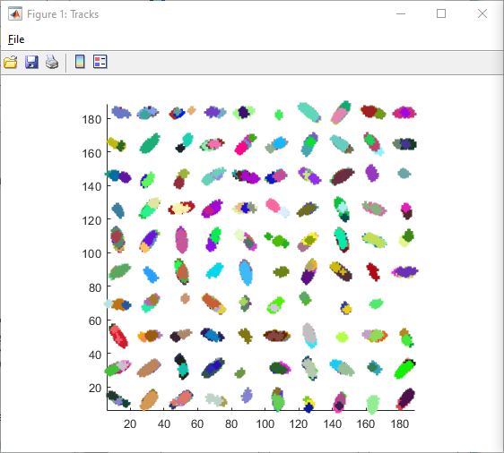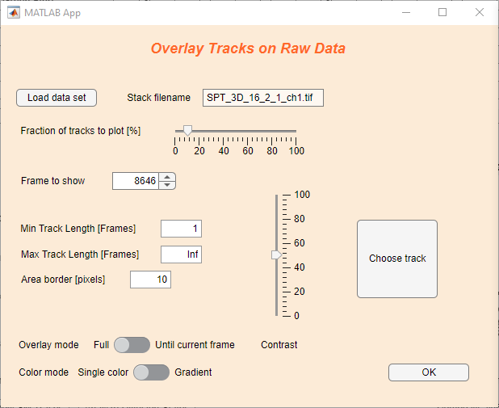

## Analyzing ensemble data

If you want to analyze ensemble data, switch to the ensemble type of SMIS data.

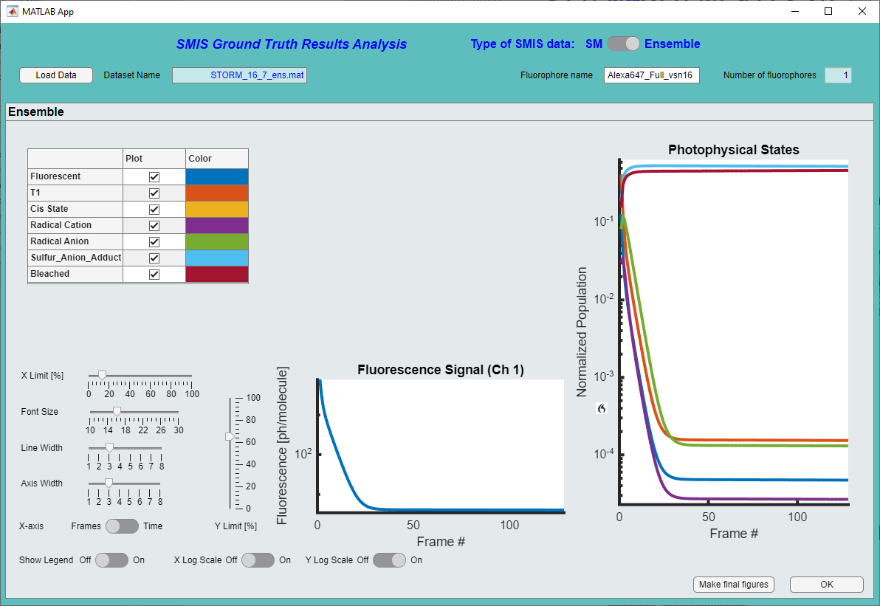The following window will appear:

Enjoy looking at data, you can select the fluorophores you want to look at, set different types of scaling, etc. and output a nice figure if needed.

# Annex 1: Content of the *sms* Matlab structure

All ground truth single molecule data are found in a Matlab structure array called ‘*sms*’. The sub-structure *sms(i).sm* will contain the data for fluorophore # *i*. The *sm* structure looks like:

sm(1:sm_par(i).n_mol)=struct(...

'x',0, ... % xyz position in current frame (may vary with drift) [in pixels] in high-resolution image

'y',0, ...

'z',0, ...

'x_track',[], ... % list of xyz positions along the diffusion track [in pixels] in high-resolution image

'y_track',[], ...

'z_track',[], ...

'sub_x',[], ... % list of xyz positions along the sub diffusion track [in pixels] if use_diffuse_psf option is used

'sub_y',[], ...

'sub_z',[], ...

'v_x',[], ... % xyz velocity in current frame (may vary with drift) [in pixels] in high-resolution image if directed diffusion is used

'v_y',[], ...

'v_z',[], ...

'c_sp',[], ... % # of the subpattern onto which the sm is placed along diffusion

'n_sp',[], ... % # of the subpattern onto which the sm is placed along diffusion when/if transition occurs

'id',0,... % id # of each molecule

'theta',sm_par(i).theta_fixed,'phi',sm_par(i).phi_fixed,... % theta & phi polar angles. Only used if anisotropy=1

'state', sm_par(i).initial_state, ... % Current photophysical state

'state_id', sm_par(i).state_ids(sm_par(i).initial_state), ... % Id of current photophysical state (several states can have the same id if they interconvert rapidly and cannot be distinguished

'state_trace', [], ... % Shows photophysical state evolution along current frame

'fluo_trace', [], ... % Shows when the molecule is in fluorescent state along current frame

'tot_state_trace', [0;sm_par(i).initial_state], ... % Shows photophysical state evolution along all frames until bleaching

'tot_fluo_trace', [], ... % Shows when the molecule is in fluorescent state along all frames until bleaching

'Ns', zeros(int8(im_par.addtime>0)+1,sm_par(i).n_states), ... % # of absorbed photons per sampling time in each starting photoactive state for addtime and frametime

'sampling_rate', nan(1,int8(im_par.addtime>0)+1), ... % local sampling rate for addtime and frametime (might differ depending on sm position)

'n_abs', zeros(1, sm_par(i).n_states), ... % # of absorbed photons (current frame)

'n_em',zeros(1, sm_par(i).n_fluorescent_states), ... % # emitted photons for each fluorescent state in current frame

'tot_n_em',zeros(1, sm_par(i).n_fluorescent_states), ... % total # of emitted photons for each fluorescent state

'n_phot_ch1', zeros(1, sm_par(i).n_fluorescent_states), ... % # emitted photons in ch1 for each fluorescent state (current frame)

'n_phot_ch2', zeros(1, sm_par(i).n_fluorescent_states), ... % # emitted photons in ch2 for each fluorescent state (current frame)

'tot_n_phot_ch1', zeros(1, sm_par(i).n_fluorescent_states), ... % total # of emitted photons in ch1 for each fluorescent state (all frames)

'tot_n_phot_ch2', zeros(1, sm_par(i).n_fluorescent_states), ... % total # of emitted photons in ch2 for each fluorescent state(all frames)

'n_phot_det_ch1', [], ... % total # of detected photons in ch1 (current frames)

'n_phot_det_ch2', [], ... % total # of detected photons in ch2 (current frames)

'tot_phot_det_ch1', 0, ... % total # of detected photons in ch1 (all frames)

'tot_phot_det_ch2', 0, ... % total # of detected photons in ch2 (all frames)

'frames_on_ch1', [], ... % frames where the molecule is on for channel 1 (ie, emits photons)

'frames_on_ch2', [], ... % frames where the molecule is on for channel 2 (ie, emits photons)

'bleached', 0, ... % 0: not bleached; 1: bleached

'activated', 0, ... % 0: not activated; 1: activated

'blinked', 0, ... % 0: not switched; 1: switched

't_on', zeros(1, sm_par(i).n_fluorescent_states), ... % time the sm is in fluorescent states (current frame)

'fr_t_on', [], ... % Fraction of times the sm is in fluorescent states (current frame) (for diffuse PSF calculations)

't_off', zeros(1, sm_par(i).n_dark_states), ... % time the sm is in dark states (current frame)

'diff_state', [], ... % Current Diffusion state

'n_diff_state', [], ... % New Diffusion state when/if transition occurs

'diff_state_trace', [;], ... % History of diffusion state

'em_spectrum',[;], ... % Emission spectrum (current frame)

'given_fret_photons',[], ... % Transfered # of photons for each fluorescent state when molecule is donor

'received_fret_photons',[], ... % Transfered # of photons for each photoactive state when molecule is acceptor

'fret_eff', 0, ... % FRET efficiency to acceptor (if donor)

'matched',0, ... % index of partner molecule (if dyes_pair_on is set)

'lx',[], ... % x linkage error [raster unit]

'ly',[], ... % y linkage error [raster unit]

'lz',[], ... % z linkage error [raster unit]

'le_set',[] ... % 1 if linkage error is set for current frame

);

# Annex 2: Content of the *sm_par* Matlab structure

For each fluorophore, some general parameters are found in the “*sm_par”* Matlab structure array. The sub-structure *sm_par(i)* will contain the parameters for fluorophore # *i*. The structure looks like:

sm_par(1:n_fluorophores)=struct(...

'fluorophore_name', [], ...

'n_mol', [], ...

'n_mol_eff', [], ...

'maturation_level', [], ...

'pH_sensitivity', 0, ...

'pH', 7.5, ...

'spectral_data', [], ...

'n_states', [], ...

'state_ids', [], ...

'initial_state', [], ...

'initial_fluo_state', [], ...

'fluorescent_states', [], ...

'associated_dark_states', [], ... % In case fluorescent states are in rapid equilibrium with dark states

'fluorescent_fraction', [], ... % In such case, fraction of the fluorescent states

'converted_state', [], ...

'bleached_states', [], ...

'trans_k', [], ...

'sampling_rate', sampling_rate, ... % sampling rate for photophysics during frametime and addtime [s-1]

'start_sampling_rate', nan(1,int8(numel(sampling_rate)==2)+1), ... % starting sampling rate for photophysics during frametime and addtime [s-1] after optimization

'trans_q', [], ...

'photoactive_states', [], ...

'quantum_yield', [], ...

'fluorogenic', [], ...

'fluorogenicity', [], ...

'psf_par_ch1', [], ...

'psf_par_ch2', [], ...

'filter_profiles', [], ...

'D', [], ...

'D_ex_rates', [], ...

'D_confined', [], ...

'D_rate_matrix', [], ...

'V', [], ...

'persistence_length', [], ...

'dispersion_selectivity', 3, ... % power factor telling how much a sm will prefer choosing wide channels relative to narrow ones

'margin_factor', 1e-5, ... % Margin factor to avoid velocity vector ending up being zero when molecule close to image border

'V_circle', [], ...

'V_init_dir', [], ...

'w_patterns', struct('w', []), ...

'anisotropy', [], ...

'dipole_orientation', [], ...

'theta_fixed', [], ...

'phi_fixed', [], ...

'jump_allowed', 0, ... % Set to 1 if stochastic reorientation allowed

'jump_rate', 0, ... % Jumping rate between fixed random orientations

'td_id', [], ... % id of tandem dye if fluorophore_pairing_on is set

'is_acceptor', 0, ... % if is_td=1, is dye an acceptor dye ?

'R0_D', [], ... % Forster radius if dye is donor

'R0_D_index', [], ... % Indices of the acceptor states able to FRET if dye is donor

'R0_A_index', [], ... % Indices of the acceptor states able to FRET if dye is acceptor

'processing_done', 0 ... % Will be set to 1 after dye is processed in FRET mode

);

# Annex 3: Content of the *im_par* Matlab structure

Finally the SMIS virtual microscope is described by some general parameters found in the “*im_par”* Matlab structure. The structure looks like:

%% Define general parameters for the images

im_par=struct(...

'n',[], ... % X size of pattern

'm',[],... % Y size of pattern

'nz',[], ... % Z size of pattern

'raster',raster,...

'binning', binning, ...

'd1d2_dist',d1d2_dist, ...

'd1d2_dist_sig', d1d2_dist_sig, ...

'd2_constrained', d2_constrained, ...

'obj', [], ... % objective parameters

'det', [], ... % detector parameters

'bg', [], ... % Background parameters

'filters', [], ... % Filters parameters

'n_images', n_images, ...

'current_frame', 0, ...

'frametime', frametime, ...

'addtime', addtime, ...

'during_frametime', [], ...

'add_drift', add_drift, ...

'add_diffusion', add_diffusion, ...

'rbox_ch1', 0, ...

'rbox_ch2', 0, ...

'distribute_in_clusters',distribute_in_clusters,...

'simul_3D',simul_3D,...

'psf_mode',psf_mode,...

'psf_astigmatism_x',psf_astigmatism_x, ...

'psf_astigmatism_y',psf_astigmatism_y, ...

'psf_n_zslices', psf_n_zslices, ...

'move_non_activated_molecules', move_non_activated_molecules, ...

'use_diffuse_psf', use_diffuse_psf, ...

'prevent_diffusion_out_FOV', prevent_diffusion_out_FOV, ...

'diffuse_psf_radius', diffuse_psf_radius, ...

'sample_zcenter', sample_zcenter, ...

'depth_of_focus', depth_of_focus, ...

'stochastic_spectrum_off',stochastic_spectrum_off,...

'two_channel', two_channel, ...

'two_channel_defocus', two_channel_defocus, ...

'two_channel_deform', two_channel_deform, ...

'single_CCD', single_CCD, ...

'mol_density', 0, ...

'fret_on', fret_on, ...

'fluorophore_pairing_on', fluorophore_pairing_on, ...

'apply_poisson_stat_for_lasers',apply_poisson_stat_for_lasers, ...

'optimize_sampling_rate', optimize_sampling_rate, ...

'minimum_oversampling', minimum_oversampling, ...

'min_sampling_points', min_sampling_points, ...

'ex_rates_min_oversampling', ex_rates_min_oversampling, ...

'rng_state', rng_state,...

'use_parallel_computing', use_parallel_computing,...

'min_n_mol_pct',min_n_mol_pct, ...

'poolobj',[], ...

'debug', debug);